**WHEN PUTTING NEW LABELS IN THE CUBBYS, MAKE SURE ALL THE LABELS ARE PLACED IN THE CORRECT CUBBY.**

**ALWAYS VERIFY THAT YOU HAVE THE CORRECT LABEL AND INGREDIENTS LABEL.**

* Take out your labels, compare them and make sure they match.
* Check the product name in the lower left corner or the lower right corner.
* **DO NOT** assume that the labels are correct simply because you got them from the right cubby.
* Ensure that Labels are placed in the correct area and that they are straight. Haphazard placement of labels makes the product look messy and cheap, this is **not the image we want to be sending to our customers.**

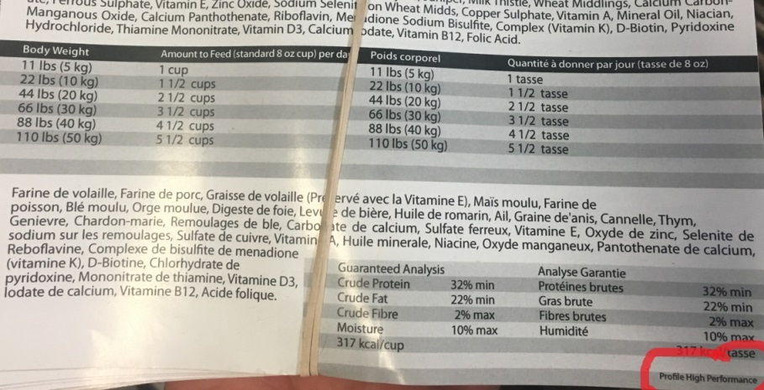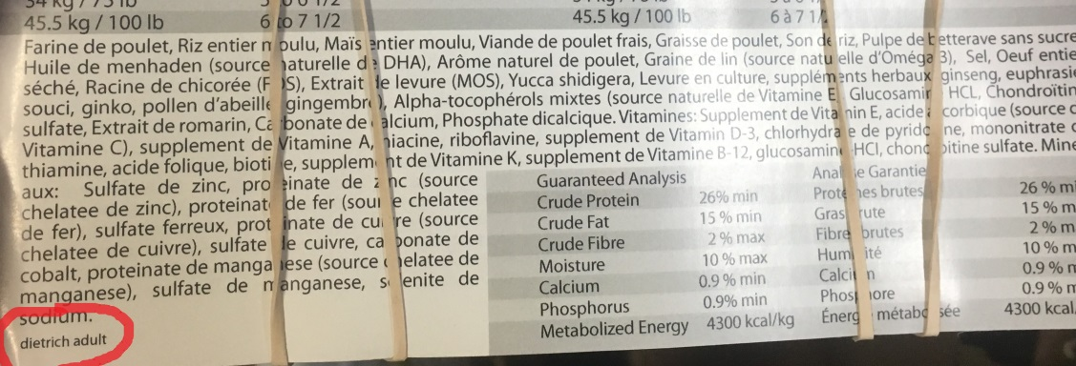

If you find any labels that are in the incorrect cubby, **please look at the other labels to see if there are any more that need to be moved to the correct spot.**

When putting labels into the cubby make sure you are putting them in the right spot. **Check the front of every stack to ensure that they are correct.**